**Prime Number:** **A number which is only divisible by 1 and itself is called prime number. Numbers 2, 3, 5, 7, 11, 13, 17, etc. are prime number**s.

1.Write a program to check a number is prime or not.

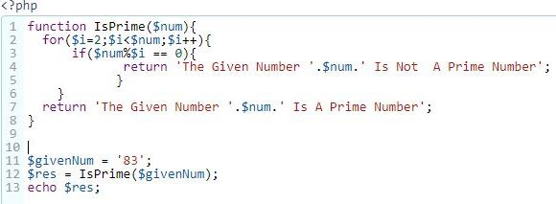

2. Write a program to print prime numbers from 1 to 100

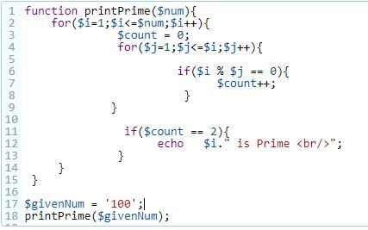

# Factorial Program: The factorial of a number n is defined by the product of all the digits from 1 to n (including 1 and n).

# EX: 4! = 4*3*2*1 = 24;

3. Write a program to find factorial of a given number

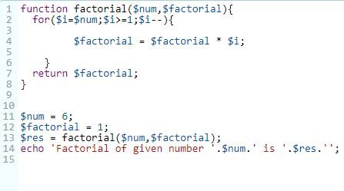

4. Write a program to check given number Armstrong or not

# Armstrong : An Armstrong number is the one whose value is equal to the sum of the cubes of its digits. 0, 1, 153, 371, 407, 471, etc are Armstrong numbers.

# C:\Users\Ravichandu Sreeram\Downloads\php program images\aramstrong.JPG

# Palindrome: A palindrome number is a number which remains same when its digits are reversed. For example, number 24142 is a palindrome number. On reversing it we?ll get the same number.

5. Write a program to check given number Palindrome or not

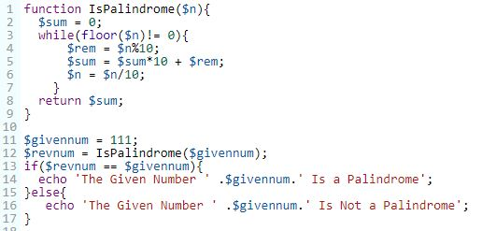

6. Write a program to check given string Palindrome or not

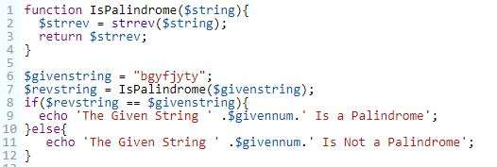

Fibonacci Series**: Fibonacci series is the one in which you will get your next term by adding previous two numbers. EX: 0 1 1 2 3 5 8 13 21 34**

**7**.Write a program to print the first 12 numbers of a Fibonacci series.

# C:\Users\Ravichandu Sreeram\Downloads\php program images\fibonacci.JPG

# Swapping two numbers: Two numbers can be swapped or interchanged. It means first number will become second and second number will become first.

# EX: a = 20, b = 30  , After swapping,  a = 30, b = 20

**7**.Write a program to swapping two numbers.

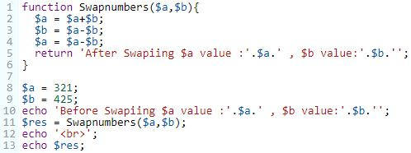

# Reverse number: A number can be written in reverse order. EX: 12345 = 54321

**8**.Write a program to reverse of a number.

# C:\Users\Ravichandu Sreeram\Downloads\php program images\reverse number.JPG

# Sum of Digits: To find sum of digits of a number just add all the digits.

**EX: 14597 = 1 + 4 + 5 + 9 + 7 ,  14597 = 26**

**9.** Write a program to find sum of digits of a number.

